**Medical Transformer**

Q). What is Medical Transformer?

* Transfer learning has gained attention in medical image analysis due to limited annotated 3D medical datasets for training data-driven deep learning models in the real world. Existing 3D-based methods have transferred the pre-trained models to downstream tasks, which achieved promising results with only a small number of training samples.
* However, they demand a massive amount of parameters to train the model for 3D medical imaging. In this work, we propose a novel transfer learning framework, called Medical Transformer.
* That effectively models 3D volumetric images in the form of a sequence of 2D image slices. To make a high-level representation in 3D-form empowering spatial relations better, we take a multi-view approach that leverages plenty of information from the three planes of 3D volume, while providing parameter-efficient training. For building a source model generally applicable to various tasks, we pre-train the model in a self-supervised learning manner for masked encoding vector prediction as a proxy task, using a large-scale normal, healthy brain magnetic resonance imaging (MRI) dataset.
* Important to note that this has same approach as ViT(vision transformer).

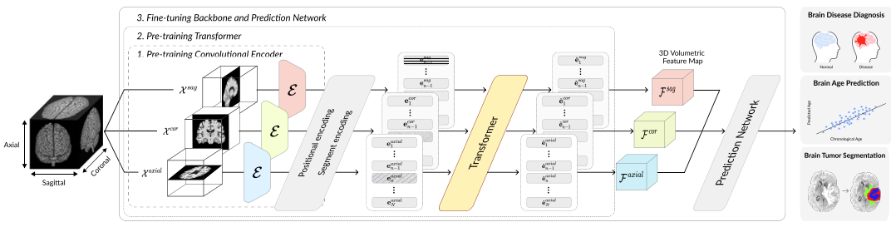

* **Schematic diagram of the proposed Medical Transformer**
* Medical Transformer: that effectively models 3D volumetric images in the form of a sequence of 2D image slices.